According to Intelli, the Slovakia orthopedic devices market was valued at USD 101.56 million in 2024 and is projected to reach USD 137.49 million by 2032, growing at a CAGR of 4.76% from 2024 to 2032.

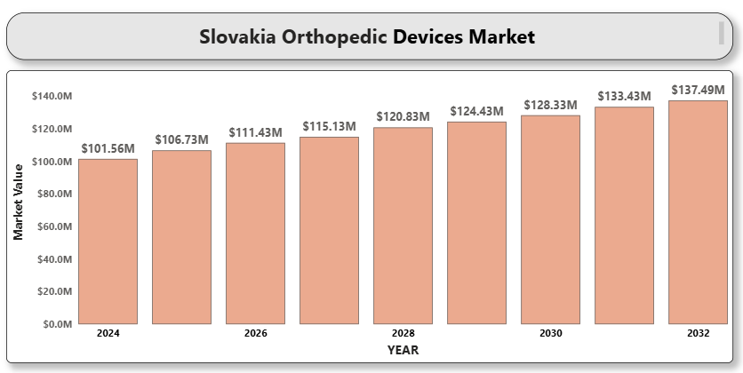

The orthopedic devices market in Slovakia is witnessing steady growth, driven by an aging population, increasing incidences of musculoskeletal disorders, and advancements in orthopedic technology. Innovations in materials and design, such as 3D-printed implants and minimally invasive surgical techniques, are enhancing treatment outcomes and patient satisfaction. Additionally, supportive government healthcare initiatives, increased healthcare spending, and a rise in sports-related injuries are propelling market demand. The expansion of healthcare facilities and rising awareness about early orthopedic interventions are expected to sustain market growth over the forecast period.

**Slovakia Orthopedic Devices Market Definition**

Orthopedic devices refer to medical instruments and implants designed to prevent or correct disorders, injuries, and deformities of the musculoskeletal system. These devices include joint reconstruction implants, spinal devices, trauma fixation devices, orthopedic braces, and arthroscopy devices. They play a critical role in restoring mobility, reducing pain, and improving the quality of life for patients. The development of orthopedic devices in Slovakia is characterized by improvements in biocompatible materials, imaging techniques, and surgical precision tools, contributing to faster recovery and better long-term outcomes.

**Slovakia Orthopedic Devices Market Overview**

The Slovakia orthopedic devices market is fueled by several key factors, including the increasing burden of orthopedic conditions such as osteoarthritis and osteoporosis, along with a growing elderly demographic. Rising demand for minimally invasive orthopedic surgeries, favorable reimbursement policies, and the integration of smart technologies into orthopedic products are also accelerating market expansion. However, challenges such as high device costs, regulatory hurdles, and limited accessibility in rural regions could restrict growth. Nonetheless, ongoing investments in R&D, coupled with collaborations between local and international companies, offer promising opportunities for market expansion.

**Slovakia Orthopedic Devices Market Segmentation Analysis**

The Slovakia Orthopedic Devices Market can be segmented based on several key categories, including product type, application, end-user, and material.

**Market Segmentation by Product Type:**

* Joint Reconstruction Devices
* Spinal Devices
* Trauma Fixation Devices
* Orthopedic Braces and Supports
* Arthroscopy Devices
* Orthobiologics

*Joint reconstruction devices* dominated the market in 2023 due to the rising number of hip and knee replacement surgeries. Improvements in implant materials and designs, such as custom-fit implants and cementless prosthetics, are fueling demand.

**Market Segmentation by Application:**

* Hip Orthopedics
* Knee Orthopedics
* Spine Orthopedics
* Craniomaxillofacial Orthopedics
* Dental Orthopedics
* Sports Injuries
* A close-up of hands holding a tablet and a pen

  Description automatically generatedTrauma and Extremities

*Hip and knee orthopedics* are leading application areas, attributed to the high prevalence of osteoarthritis among Slovakia's aging population. Sports injuries are also a rapidly growing segment due to the increasing popularity of recreational sports.

**Market Segmentation by End-User:**

* Hospitals
* Orthopedic Clinics
* Ambulatory Surgical Centers (ASCs)
* Homecare Settings

*Hospitals* represent the largest end-user segment, benefiting from advanced surgical infrastructure and the availability of multidisciplinary orthopedic teams. Meanwhile, orthopedic clinics and ASCs are gaining traction for elective procedures.

**Market Segmentation by Material:**

* Metallic Biomaterials
* Ceramic Biomaterials
* Polymeric Biomaterials
* Natural Biomaterials

*Metallic biomaterials*, including titanium and stainless steel, dominate the market due to their durability and mechanical strength, essential for load-bearing orthopedic applications.

**Key Players**

The "Slovakia Orthopedic Devices Market" study report will provide valuable insight, emphasizing the Slovakian market. Major players include Zimmer Biomet Holdings, Inc., Stryker Corporation, Johnson & Johnson (DePuy Synthes), Smith & Nephew PLC, Medtronic PLC, B. Braun Melsungen AG, DJO Global, NuVasive, Inc., Globus Medical, Inc., and Arthrex, Inc. The report also includes financial insights, product benchmarking, and SWOT analysis for these companies.

**Key Developments**

* In 2023, Zimmer Biomet launched "Persona IQ," the first smart knee implant, in Slovakia, offering remote post-surgical monitoring.
* In 2024, Stryker expanded its partnership with local Slovakian healthcare providers to introduce advanced robotic-assisted orthopedic surgeries.
* In 2025, Smith & Nephew introduced a next-generation hip implant designed for improved longevity and mobility, tailored to the European market, including Slovakia.

**Market Attractiveness**

An analysis of market attractiveness highlights the strong potential of Slovakia’s urban regions, where advanced healthcare infrastructure and higher disposable incomes are promoting the adoption of orthopedic technologies. Key influencing factors include aging demographics, technological advancements, and government health initiatives.

**Porter's Five Forces**

Using Porter's Five Forces framework, the Slovakia orthopedic devices market analysis reveals:

* Moderate competitive rivalry due to established players and local entrants
* Moderate to high threat of new entrants driven by technological innovation
* Moderate threat of substitutes, such as physical therapy for early-stage orthopedic conditions
* A close-up of hands holding a tablet and a pen

  Description automatically generatedHigh bargaining power of suppliers in specialized materials
* High bargaining power of buyers in public healthcare contracts

**TABLE OF CONTENTS**

**1 INTRODUCTION OF SLOVAKIA ORTHOPEDIC DEVICES MARKET**

* Overview of the Market
* Scope of Report
* Assumptions

**2 EXECUTIVE SUMMARY**

**3 RESEARCH METHODOLOGY**

* Data Mining
* Validation
* Primary Interviews
* List of Data Sources

**4 SLOVAKIA ORTHOPEDIC DEVICES MARKET OUTLOOK**

* Overview
* Market Dynamics
  + Drivers
  + Restraints
  + Opportunities
  + Trends
* Porters Five Force Model
* Value Chain Analysis

**5 SLOVAKIA ORTHOPEDIC DEVICES MARKET, BY PRODUCT TYPE**

* Joint Reconstruction Devices
* Spinal Devices
* Trauma Fixation Devices
* Orthopedic Braces and Supports
* A close-up of hands holding a tablet and a pen

  Description automatically generatedArthroscopy Devices
* Orthobiologics

**6 SLOVAKIA ORTHOPEDIC DEVICES MARKET, BY APPLICATION**

* Hip Orthopedics
* Knee Orthopedics
* Spine Orthopedics
* Craniomaxillofacial Orthopedics
* Dental Orthopedics
* Sports Injuries
* Trauma and Extremities

**7 SLOVAKIA ORTHOPEDIC DEVICES MARKET, BY END-USER**

* Hospitals
* Orthopedic Clinics
* Ambulatory Surgical Centers (ASCs)
* Homecare Settings

**8 SLOVAKIA ORTHOPEDIC DEVICES MARKET, BY MATERIAL**

* Metallic Biomaterials
* Ceramic Biomaterials
* Polymeric Biomaterials
* Natural Biomaterials

**9 SLOVAKIA ORTHOPEDIC DEVICES MARKET COMPETITIVE LANDSCAPE**

* Overview
* Company Market Ranking
* Key Development Strategies

**10 COMPANY PROFILES**

**10.1 Zimmer Biomet Holdings, Inc.**

* 10.1.1 Overview
* 10.1.2 Financial Performance
* 10.1.3 Product Outlook
* 10.1.4 Key Developments

**10.2 Stryker Corporation**

* 10.2.1 Overview
* 10.2.2 Financial Performance
* 10.2.3 Product Outlook
* 10.2.4 Key Developments

**10.3 Johnson & Johnson (DePuy Synthes)**

* 10.3.1 Overview
* 10.3.2 Financial Performance
* 10.3.3 Product Outlook
* 10.3.4 Key Developments

**10.4 Smith & Nephew plc**

* 10.4.1 Overview
* 10.4.2 Financial Performance
* 10.4.3 Product Outlook
* 10.4.4 Key Developments

**10.5 Medtronic PLC**

* 10.5.1 Overview
* 10.5.2 Financial Performance
* 10.5.3 Product Outlook
* 10.5.4 Key Developments

**10.6 Arthrex, Inc.**

* 10.6.1 Overview
* 10.6.2 Financial Performance
* 10.6.3 Product Outlook
* 10.6.4 Key Developments

**10.7 Globus Medical**

* 10.7.1 Overview
* 10.7.2 Financial Performance
* 10.7.3 Product Outlook
* 10.7.4 Key Developments

**10.8 B. Braun Melsungen AG**

* 10.8.1 Overview
* 10.8.2 Financial Performance
* 10.8.3 Product Outlook
* 10.8.4 Key Developments

**10.9 ConMed Corporation**

* 10.9.1 Overview
* 10.9.2 Financial Performance
* 10.9.3 Product Outlook
* 10.9.4 Key Developments

**10.10 DJO Global, Inc.**

* 10.10.1 Overview
* 10.10.2 Financial Performance
* 10.10.3 Product Outlook
* 10.10.4 Key Developments

**11 KEY DEVELOPMENTS**

* Product Launches/Developments
* Mergers and Acquisitions
* Business Expansions
* Partnerships and Collaborations

**12 APPENDIX**

* Related Research